**Data Gathering and understanding/Analyzing**

**Table 4.2** Basic items of the QS

|  |  |  |  |  |  |  |
| --- | --- | --- | --- | --- | --- | --- |
| 1. **Excavation**: In the soil of the site, whether the soil is cohesive or incoherent or soil sand, slag or rock depending on the soil and sandy or disintegrated soil will need to support the sides so as not to collapse, which increases the cost of drilling.  **Unit of calculation**: in cubic meters.  **How to measure**: The measurement is geometrical according to the approved engineering drawings. | | | | | | Image result for digging works |
| 2. Ordinary concrete for foundation: whether this layer is a cleaner layer or a layer resistant to the stresses and loads coming from reinforced concrete.  The components of the cubic meter of concrete are determined by the Consultationoffice as well as the technical specifications, which are usually at a rate for cement: sand: gravel, measuring it in cubic meters plus water for mixing. **Unit of calculation**: in cubic meters. **How to measure**: The measurement is geometrical according to the approved engineering drawings. | | | | | | Image result for Ordinary concrete   construction  work |
|  |  | | | | |  |
|  |  | | | | |
| 3. **Reinforced concrete for foundations**: This layer depends on the type of foundations, whether concrete or separate or connected or common rules or (garages). The cubic meter components of the concrete are determined by the Consultationoffice as well as by the technical specifications which are usually at a rate for cement: sand: gravel, measuring it in cubic meters plus water for mixing..  **Unit of calculation**: in cubic meters.  **How to measure**: The measurement is geometrical according to the approved engineering drawings. | | | |  | | |
| 4. **Isolation of foundations**: The foundations are isolated by bitumen or insulation with any alternative materials, the purpose of which is isolation from the water and the harmful salts found in the soil.  **Unit of calculation**: flat or full-size (agreement).  **How to measure**: The measurement is geometrical according to the approved engineering drawings. | | | |  | | |
| 5. **Soil Compaction**: After insulation, the foundations shall be laid and the surface leveled at the required levels. Unit of calculation: in cubic meters.  **How to measure**: The measurement is geometrical according to the approved engineering drawings. | | | | | Image result for Dredging in construction | |
| 6. **Columns of the ground floor**: The columns of the ground floor are carried out to the specific levels associated with the height of the ground floor as well as the existence of the ladder. The cubic meter components of the concrete are determined by the Consultationoffice as well as by the technical specifications, which are usually at a rate for cement: sand: gravel, measuring it in cubic meters plus water for mixing.  **Unit of calculation**: in cubic meters.  **How to measure**: The measurement is geometrical according to the approved engineering drawings. | | | |  | | |
| 7. **Ceiling of the ground floor**: This ceiling is poured after the work of the jacks required to carry the origin when the concrete in the initial case is not able to endurance and also after placing the reinforcing steel with diameters and distances specified by the designer. The cubic meter components of the concrete are determined by the Consultationoffice as well as by the technical specifications, which are usually at a rate for cement: sand: gravel, measuring it in cubic meters plus water for mixing.  **Unit of calculation**: in cubic meters.  **How to measure**: The measurement is geometrical according to the approved engineering drawings. | | | Image result for Ceiling of the ground floor | | | |
| 8. **Block works**: in which the walls are built with the required thickness and height and the required openings are left architecturally for doors and windows.  The components of the m3 of the mortar are determined by the Consultationoffice as well as technical specifications, which are usually at a rate for cement: sand: gravel, measuring it in cubic meters plus water for mixing.  **Unit of calculation**: in meter length  **How to measure**: The measurement is geometrical according to the approved engineering drawings with the download of the openings. | | | Image result for Ceiling of the ground floor | | | |
| 9. **Carpentry work**: It is installed doors and windows.  **Unit of calculation**: per piece.  **How to measure**: Count the number of doors and windows according to different models. | | Image result for Carpentry work | | | | |

|  |  |  |  |
| --- | --- | --- | --- |
| 10. **Polishing White works**: internal or external.  Unit of calculation: flat surface.  **How to measure**: The measurement is geometrical according to the approved engineering drawings with the download of the large openings. | | Image result for spatter dash  White works construction | |
| 11. **Flooring works**: from tiles, ceramics and ordinary concrete.  **Unit of calculation**: flat surface.  **How to measure**: The measurement is geometrical according to the approved engineering drawings. | Image result for Flooring works construction | | |
| 12. The works of the ironworks: the works of iron metal.  Unit of calculation: by weight.  How to measure: The measurement is geometrical according to the approved engineering drawings. | | | Image result for The works of the ironworks  works construction |

Screen Shoots of the application

Data Base Scheme

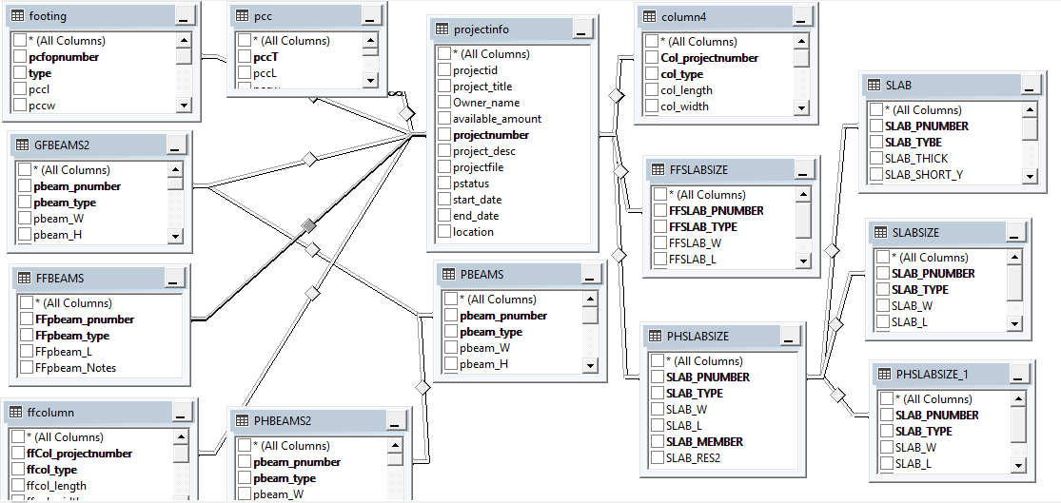

|  |  |
| --- | --- |
| Project information Form | Related table |
|  |  |
|  |  |

**Figure4.1** Project registration form

The Project registration form demonstrated the Initial step of completing the QS Tasks,

The user needs, to register the project and to enter main information about the project , the information linked to the main database with table name called “projectinfo”, Therefore to keep the various projects secure and managed and easy to access considering ‘CRUD’ operations i.e. Create, Read, Update and Delete ,So only the correct project will be effected after the CRUD operation .

|  |  |
| --- | --- |
|  |  |
|  |  |

**Figure4.2** Project Log In screen

The Log In screen demonstrated to perform the security function for validating the authorized user to access their related project and to offer the correct environment to the related project.

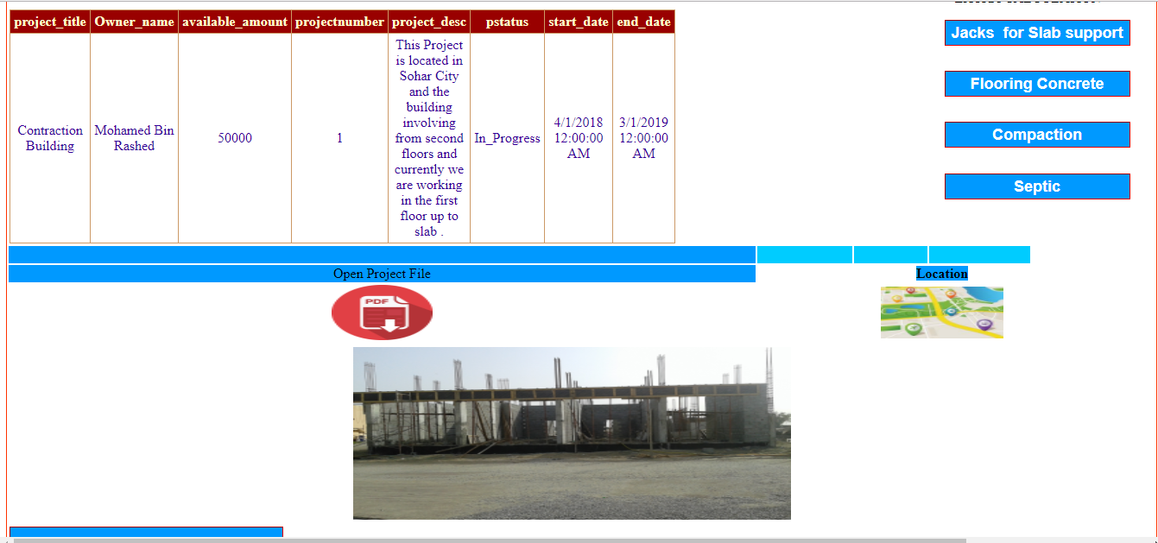

**Figure 4.3** Project Basic Information web page

The Project Basic Information web page shows the main information from table ‘project info’, that have been entered in Figure 4.1 Project registration form,

The user could captured the basic project information as well as can read the project information file that have been attached to the project

The user also could access the location of the project , based on the project Image that have been taken from the real project location .

When the user click the “open Project File ” Icon the project file opened in a pop up screen as shown in figure 4.4

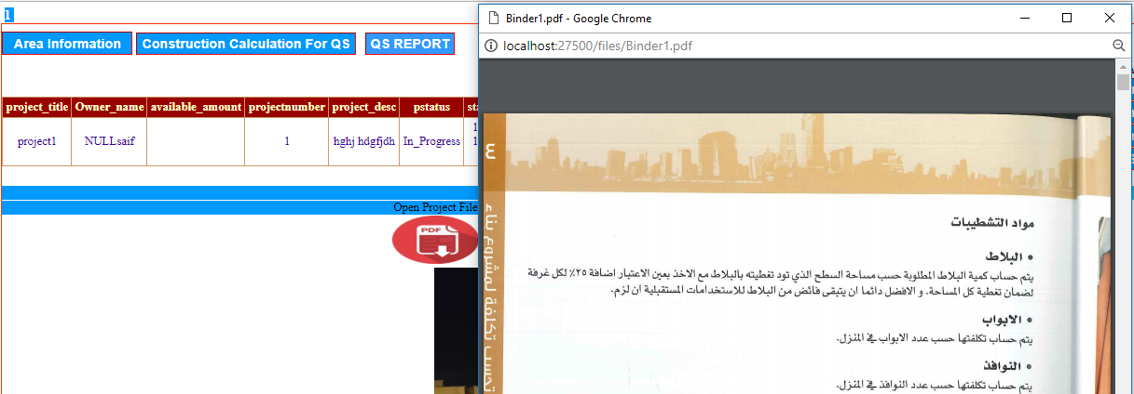

**figure 4.4** Open attached file screen

When the user click the location image the system will identify and extract the Image location information and pass it to google map satellite to show the location of the project ,Figure 4.5 display a sample of discovering the project location

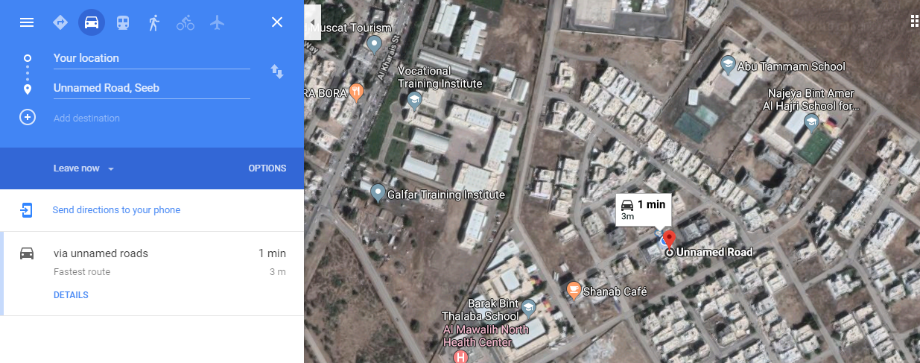

**Figure 4.5** Locating the project location screen

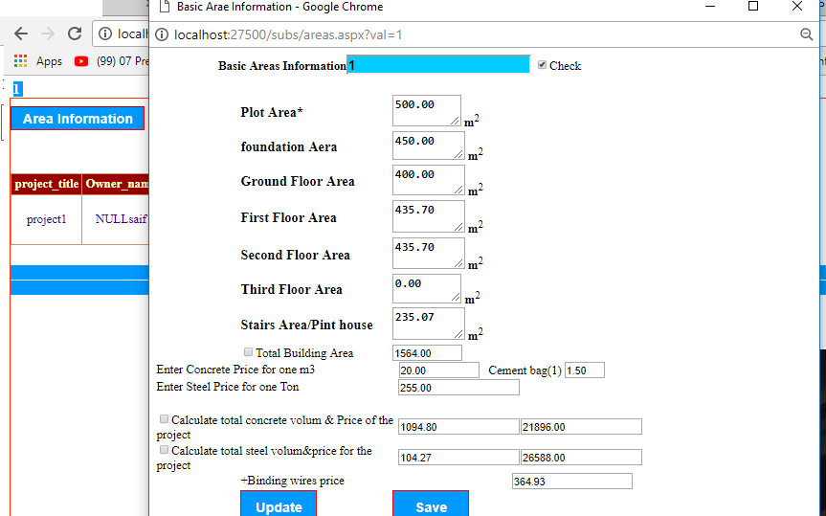

**Figure 4.6** Project Area and main price information

The user start with entering building Areas using Area web page as described in figure 4.6 , this screen allow the user to save the information and update when its necessary ,for example when the price changed etc…

After entering the project areas information the user can generate the first QS report as described in figure 4.7 ,the information that demonstrated in the firs report are not accurate to be used as a final QS report , this is just a report that generated based on previous projects with similar areas information ,however such approach is not recommended since there are many nuances related to the QS which could play main role in affecting the QS report information .

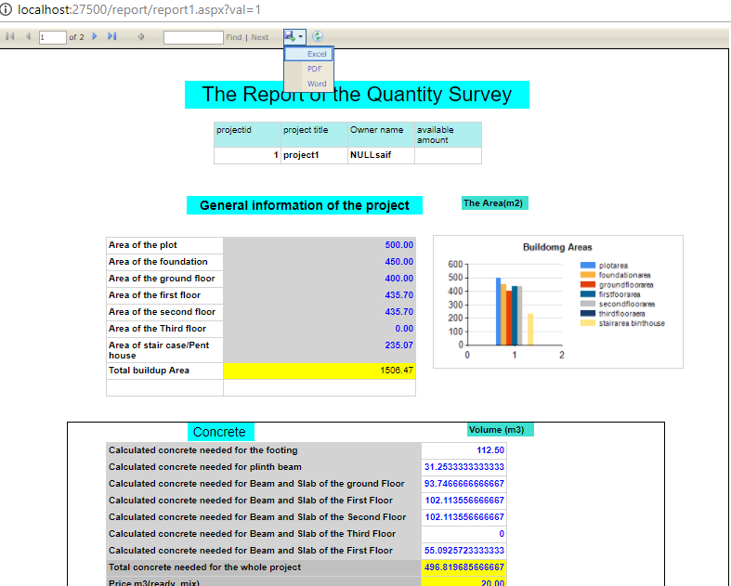

**Figure 4.7** Predicted QS first report

As shown in figure 4.7 the system provide save feature which allow the user to save the report in different format i.e. Word , Excel and PDF , this will help for professional presentation . as well as with navigation ,print ,refresh, size and search features .

When the user click the “construction calculation for QS “ command Figure 4.8 appears to allow the user to choose over sub structure and super structure QS operation respectively .

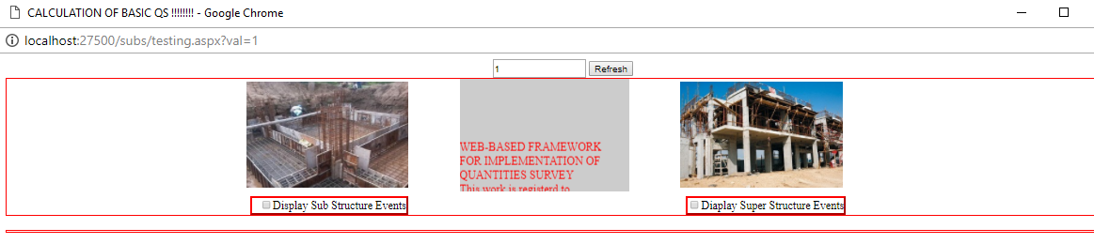

**Figure 4.8** QS Sub and Super structure categories

When the user click the “Display Sub Structure Events “ check box or the image above the checkbox , new screen described in figure 4.8 appears to demonstrate all sub structure operations related to the QS, the as we can noted that the project number is attached with all screen to make sure that the system will save and update the information to the correct table .

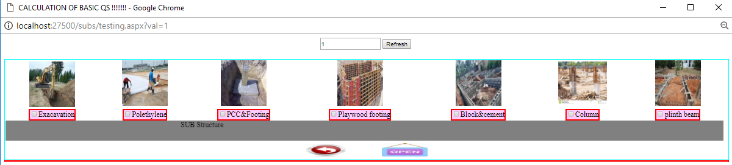

**Figure 4.9** Sub structure operation screen

The screen work as a sub hub to manage the QS workflow of sub structure operations starting from Excavation, Polyethylene ,PCC etc.… up to the plinth beam tasks .

When the user click the Excavation checkbox ,figure 4.9 appears to allow the user to update the Excavation information related to the selected project .

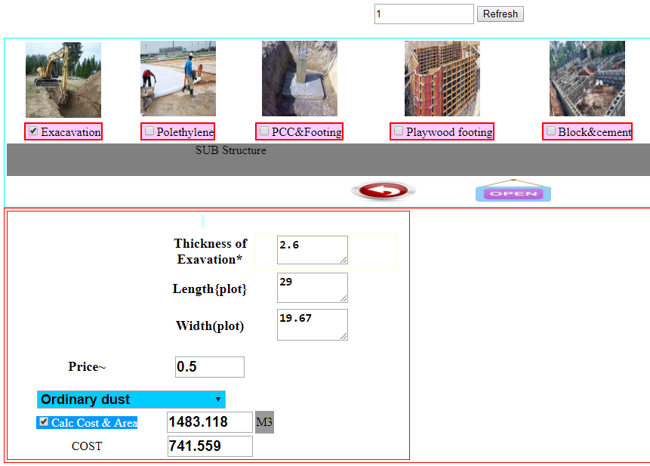

**Figure 4.10** QS Excavation information Form

When the user click the “calc cost and area “check box the system is expected to update the information to the related table as well as the system will notify the user with pop up message about the status of the operation as shown in figure 4.10 .



**Figure 4.11** user massage after any CRUD operation

When the user click the “Polethlene” checkbox , figure 4.11 appears to allow the user to update the QS Polyethylene tasks .

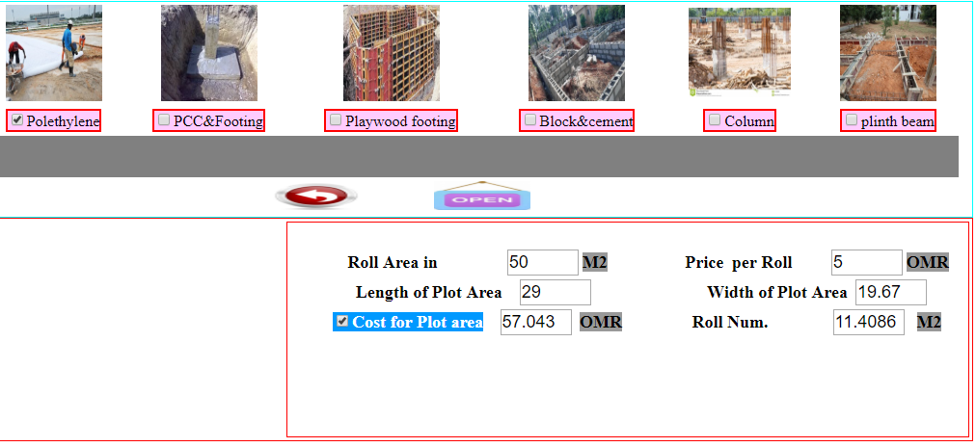

**Figure 4.12** QSPolyethylene

When the user click the PCC & Footing checkbox, Figure 4.12 appears to allow the user to enter the PCC Data obtained from the building consult company , after what the user in one click could obtained the Pcc Information as shown in figure 4.13 i.e. the volume of the Pcc ,Footing Steel , Footing concrete and the footing Binding wires

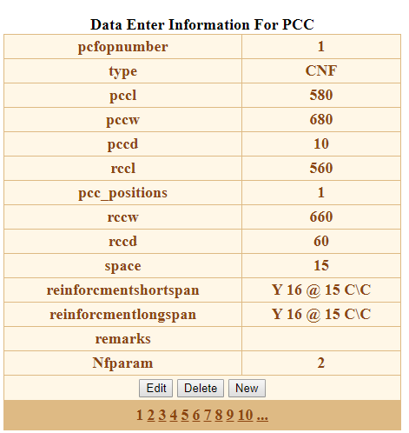

**Figure 4.13** Footing data entry form

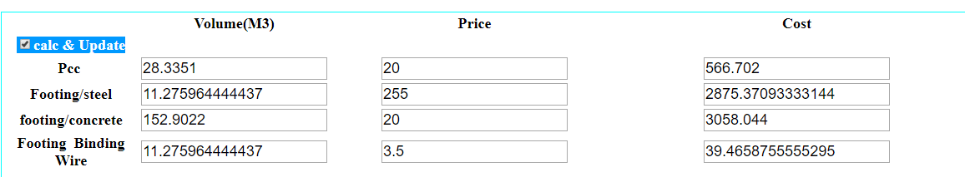

**Figure 4.14** footing information update screen

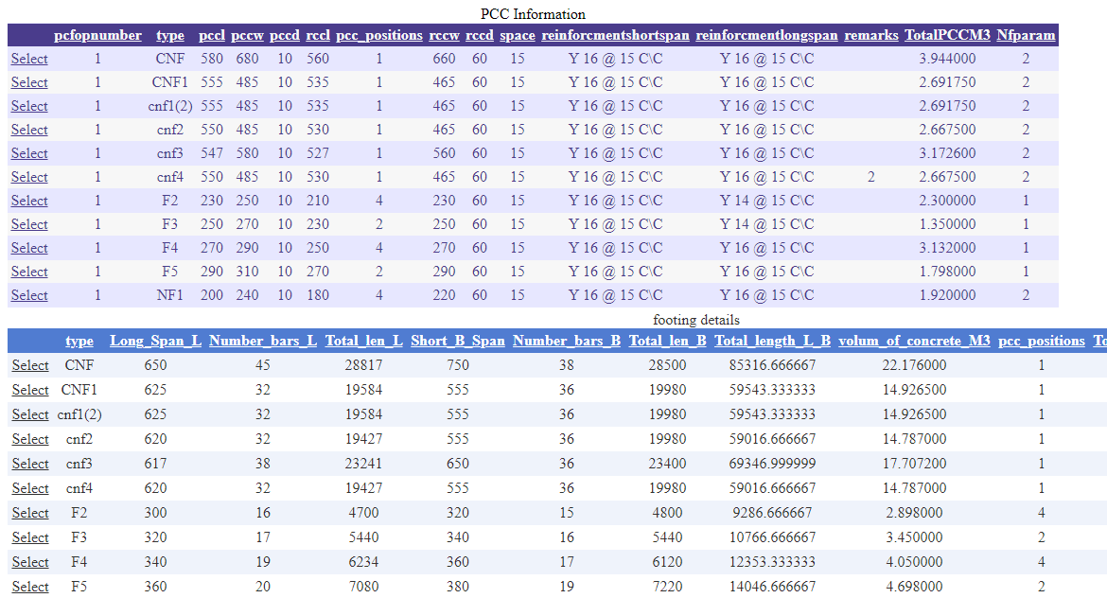

**Figure 4.15** Details of Concrete Footing calculation screen

The Details of Concrete Footing calculation screen allow the user to capture the concrete calculationdetails.

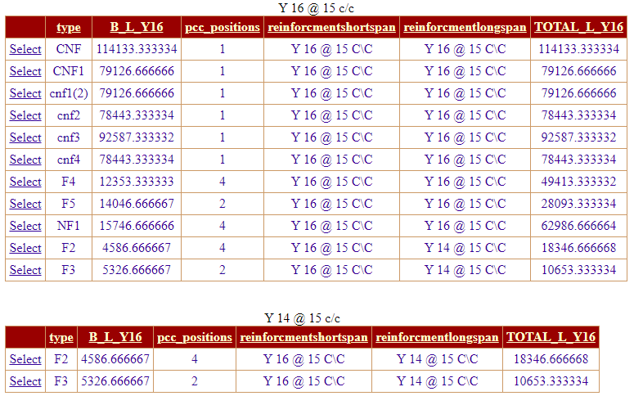

**Figure 4.16** Details of Steel Footing calculation screen

The Details of Steel Footing calculation screen allow the user to capture the steel calculation details of the footing phase .

“The information appears in figure 4.13 1nd figure 4.14 are generated automatically during data entry without the user intervention.”

“When the user click the plywood footing checkbox , Figure 4.15 appears , the information also generated automatically without the user intervention , based on the data that have been pass in as described in figure 4.11 .”

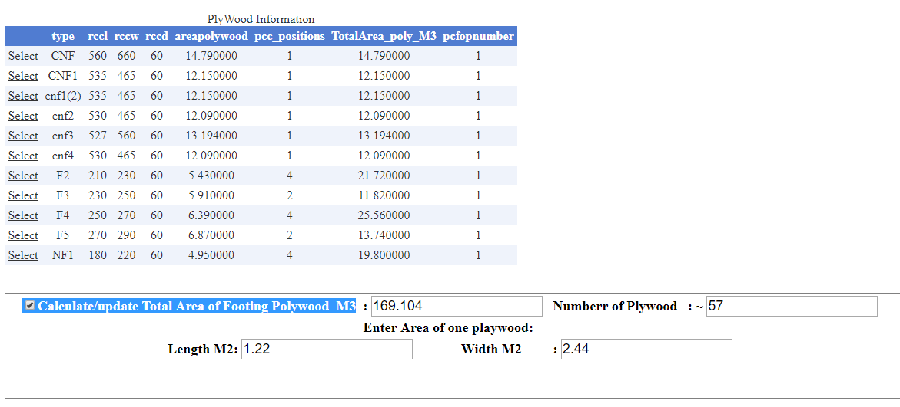

**Figure 4.17**Plywood footing information

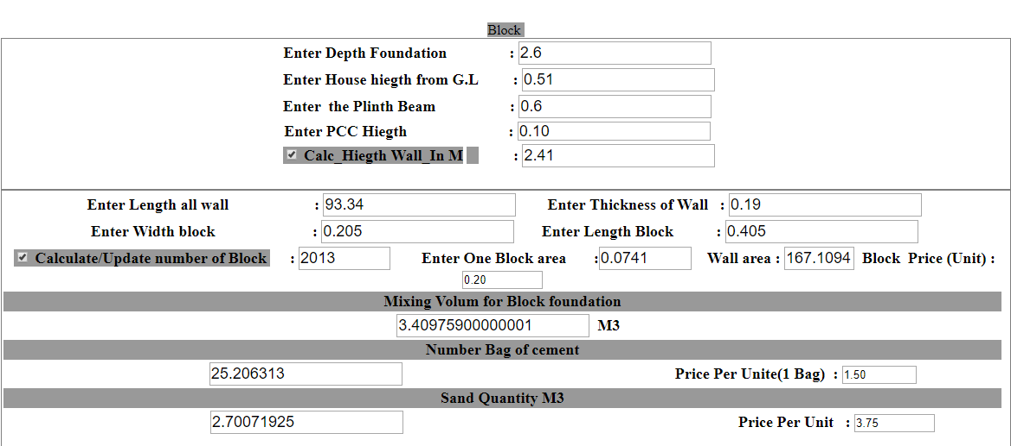

**Figure 4.18** Block Information screen

“The Block Information screen also generated based on the project data set.

The screen coming on when the user click the checkbox control.”

“Column Operation:

When the user click the column checkbox, Figures 4.17 ,4.18,4.19 appears to demonstrate the data entry of column and all other related task.”

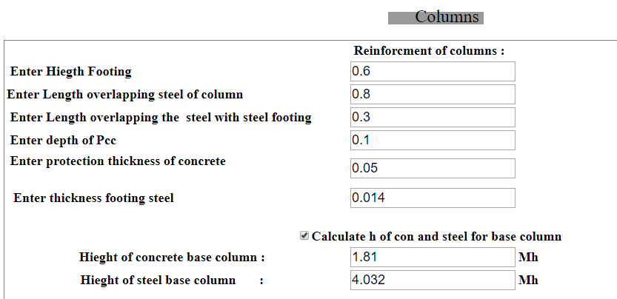

**Figures 4.19**

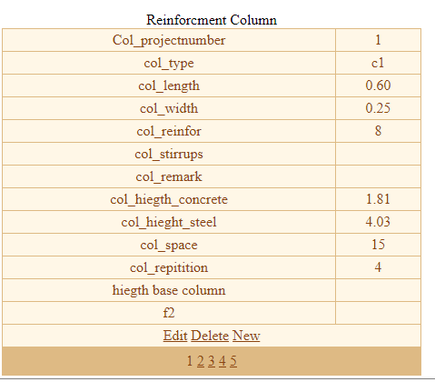

**Figure 4.20**

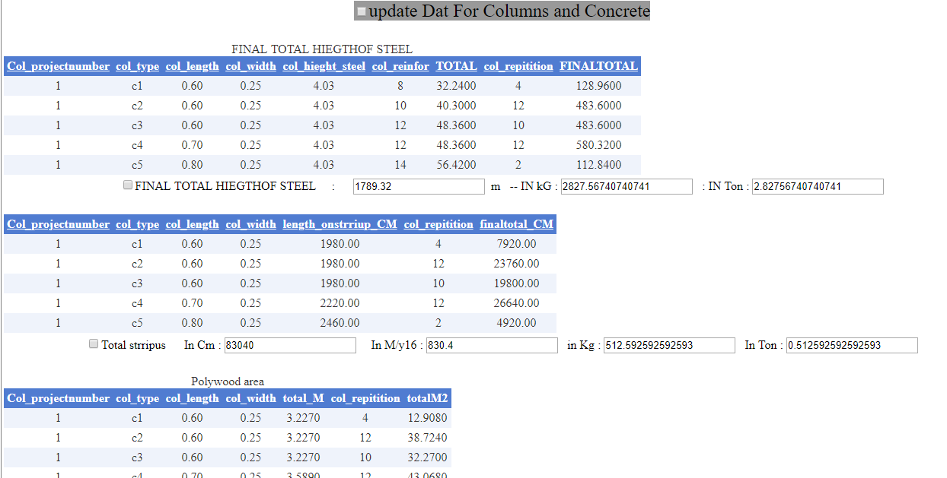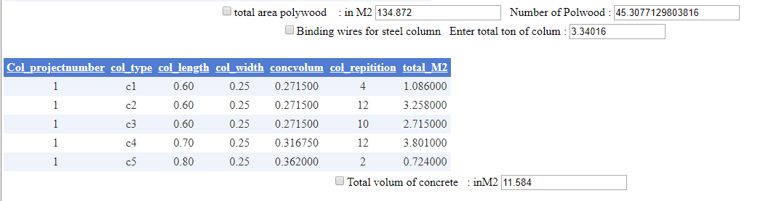

**Figure 4.21**

“Figure 4.21shows the Plainth Beam operations “.

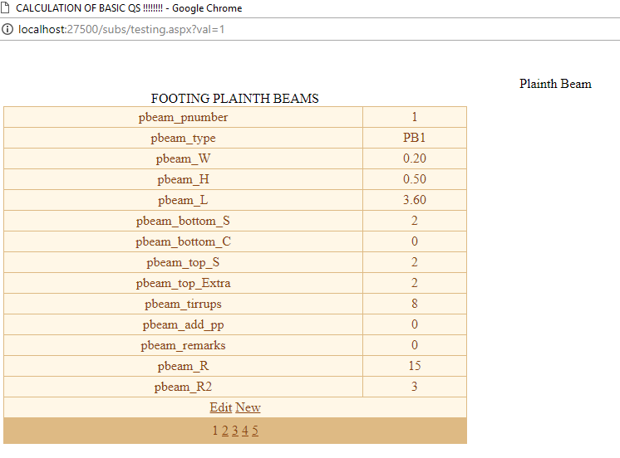

**Figure 4.21** Plainth data entry form

“Figure 4.21 demonstrate the calculation details of the plainth beams operation , which is in fact generated automatically by the system considering the data that have been entered in figure 4.20”

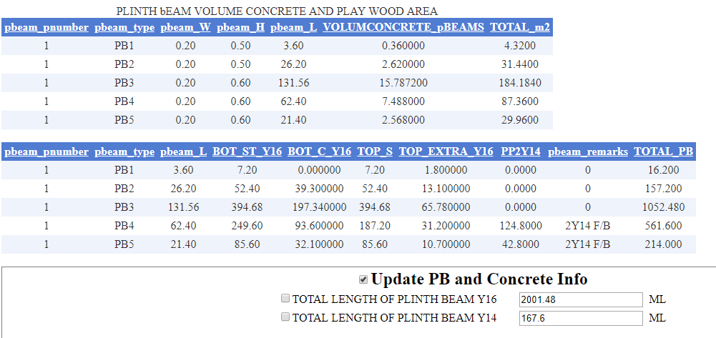

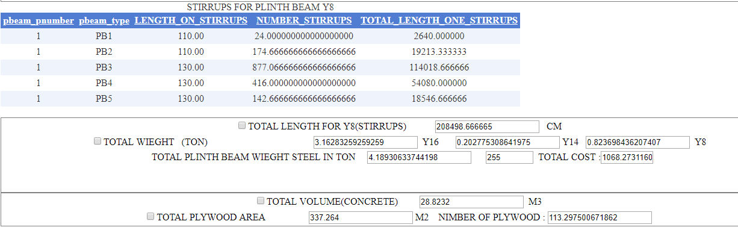

Super Structure

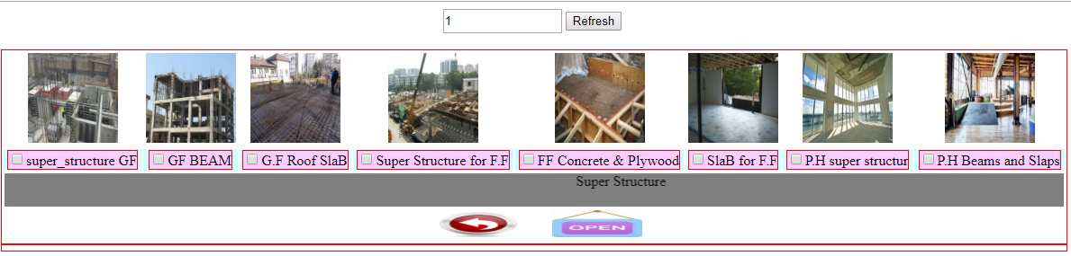

**Figure 4.22** Main window screen for super structure tasks

The Main window screen for super structure tasks allow the user to discover the various operations related to the super structure tasks , Therefore when the user click the “ super_structure GF” CheckBox ,the “GF” stands for Grand Floor ,figure 4.23 demonstrate the contents of this screen .

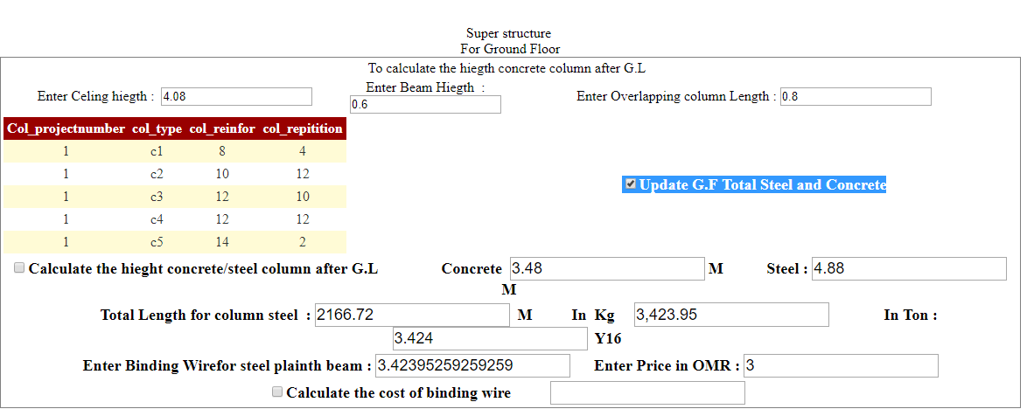

**Figure 4.23** GF Steel and Concreate calculation screen

In one click the user will obtain the Total length of required column steel volume as well as for the required concrete needs for the ground floor (GF). And the system will also calculate the same for the Stirrups steel ,concrete and plywood , figure 4.24 shows the details of the calculation .

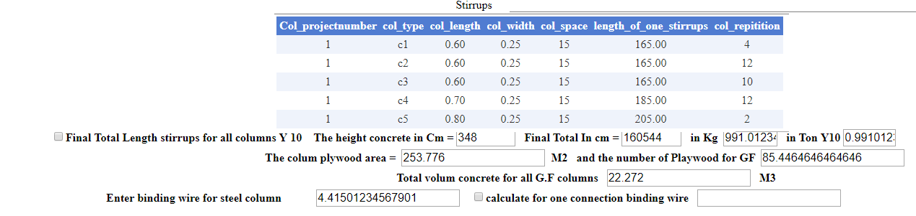

**Figure 4.24** Stirrups calculation screen

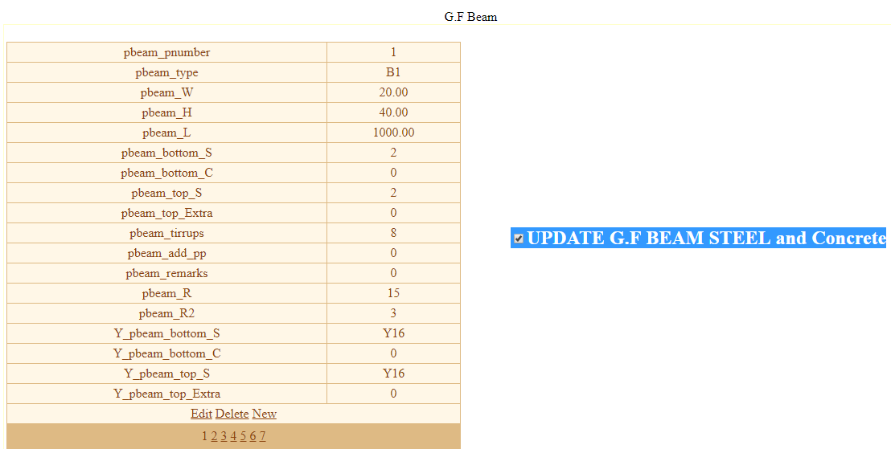

**Figure 4.25** Grand Floor Beams screen

The Grand Floor Beams screen allow the user to enter the data about the Ground floor beams which in fact proposed by the consultant company , in addition to that the screen allow also the user to perform the CRUD Database operations . Figure 4.25 and 4.26 demonstrated the generated screens for more details related to the results.

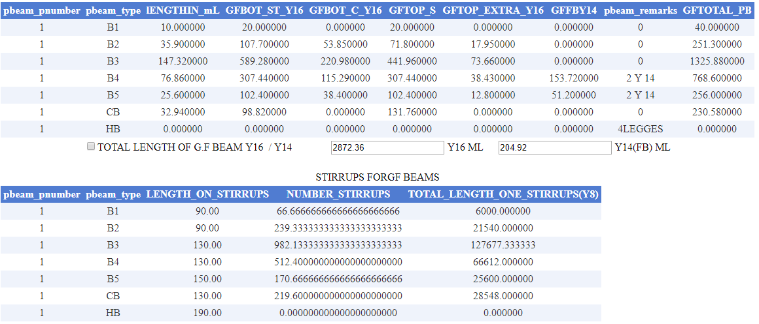

**Figure 4.26** Details screen for GF Beams calculations

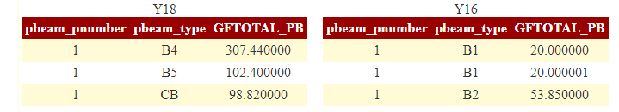

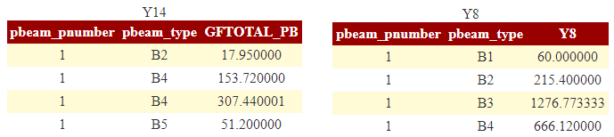



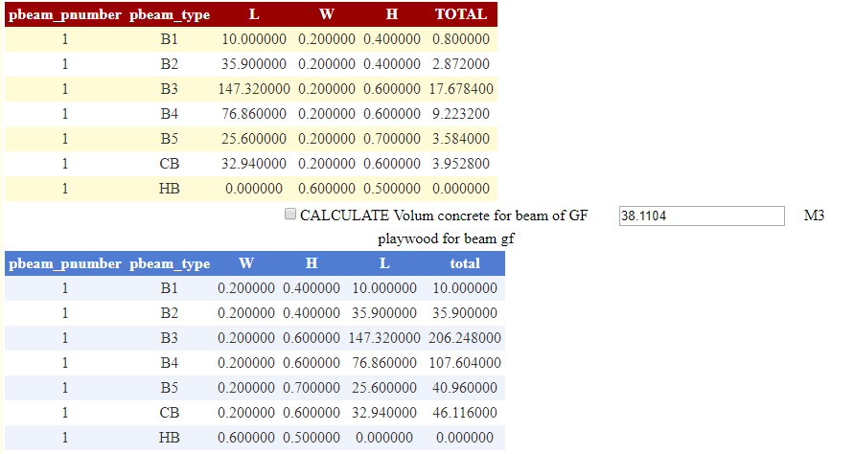

**Figure 4.27** Details screen for GF Plywood Beams calculations

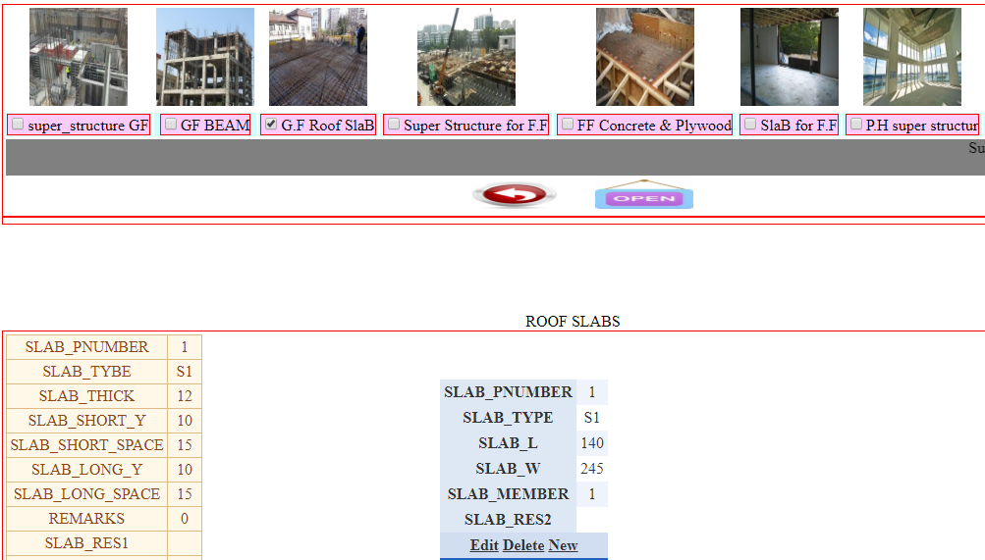

**Figure 4.28** Roof Slabs Screen Data Entry

The Roof Slabs Screen Data Entry allow the user to perform CRUD operation related to the Slab Tasks .

